Appendix E – Client Engagement activities

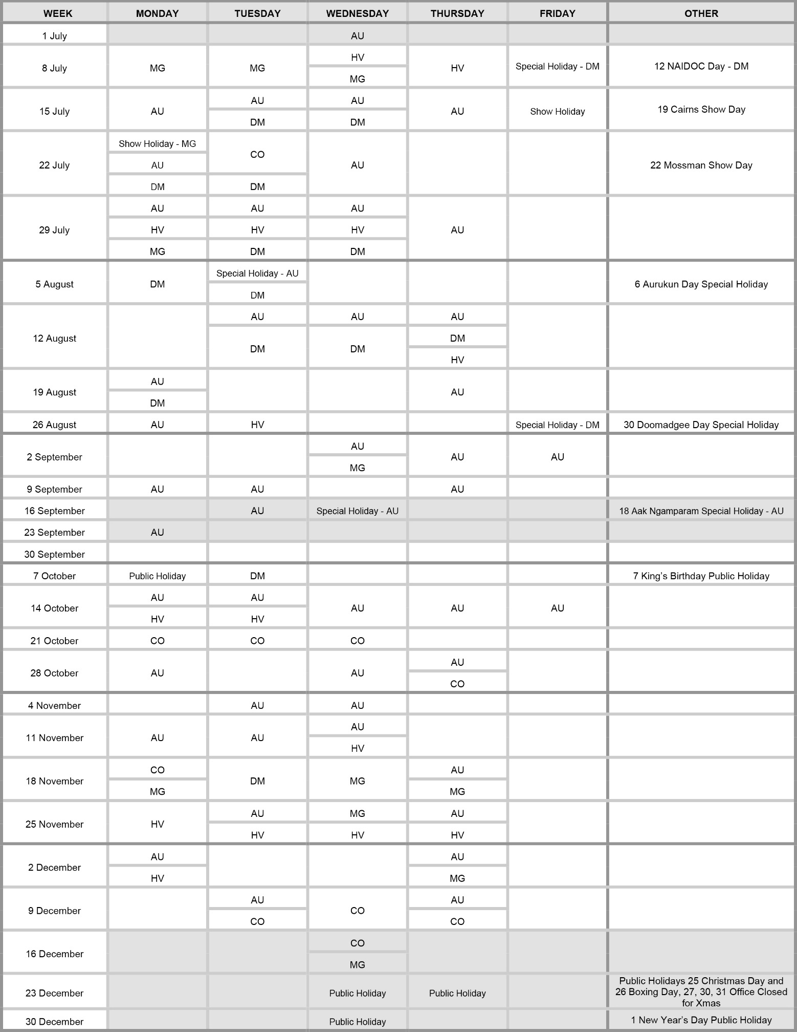
Family Responsibilities Commission 1 July 2024 to 31 December 2024

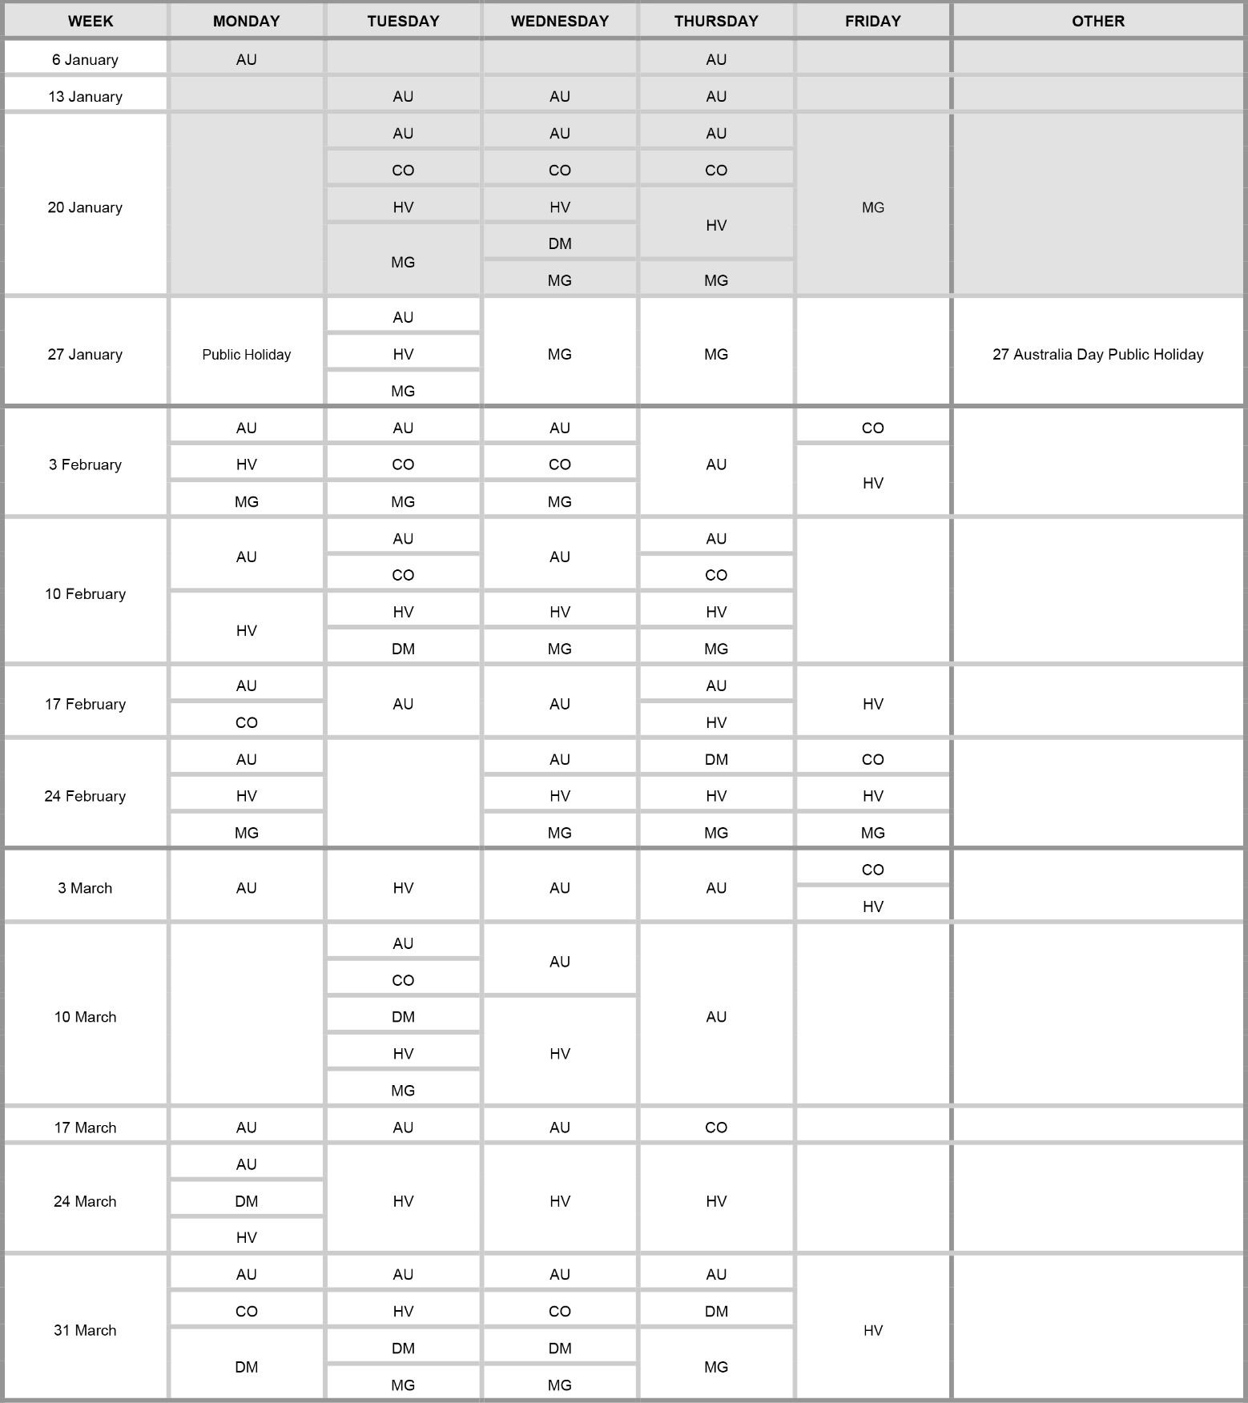
Family Responsibilities Commission 1 January 2025 to 6 April 2025

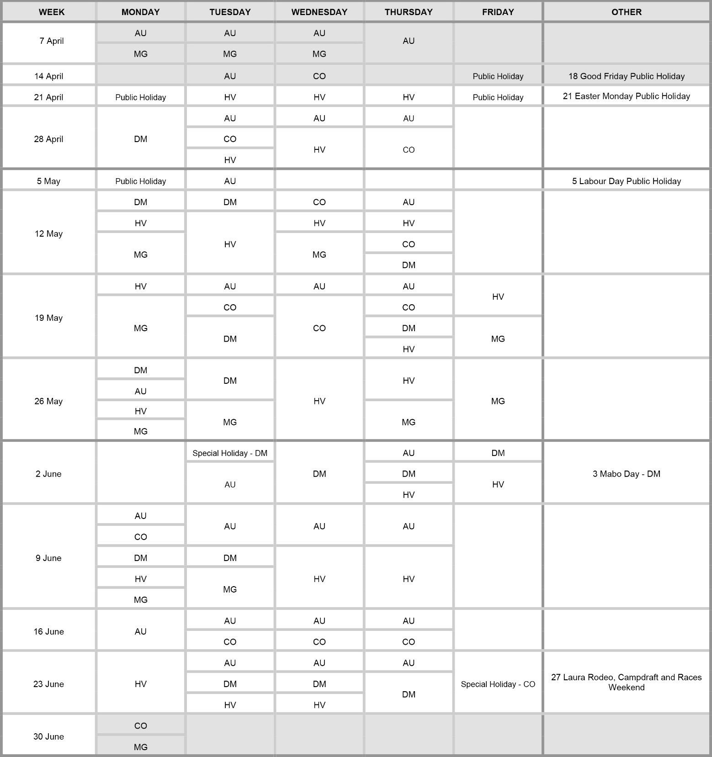
Family Responsibilities Commission 7 April 2025 to 30 June 2025

